|  |  |
| --- | --- |
| Assessment Title | Industry Legislation & Organisational COE Assignment |

## Competency Details

|  |  |
| --- | --- |
| Unit code/s and title/s | ICTICT532 Apply IP, ethics and privacy in ICT environments |
| Qualification code/s and title/s | ICT50220 Diploma of Information Technology |
| Business unit/Work group | Business and Art / IT Studies |

## Instructions

|  |  |
| --- | --- |
| Method/s of assessment | Product & Questioning (Written) |
| Overview of assessment | This assessment will require you to identify, review and suggest improvements to existing IP, ethics and privacy policy procedures at ITWorks. |
| Task/s to be assessed | This assessment will require you to complete the following tasks   * show understanding of legislative requirements * apply legislative requirements to existing IP, ethics and privacy policy procedures at ITWorks * evaluate the current IP, ethics and privacy policies and procedures at ITWorks * review potential updates of IP, ethics and privacy policy procedures at ITWorks including email reports/notifications to ITWorks staff * implement IP, ethics and privacy policies and procedures updates at ITWorks and communicate changes to all staff at ITWorks * develop a grievance procedure at ITWorks and forward to ITWorks management |
| Time allowed | Refer to your schedule for submission dates |
| Location of assessment | Assessment can be completed anywhere with access to the resources required. (see Resources Required section below) |
| Decision making rules | To receive a satisfactory outcome for this assessment you must complete all parts correctly.  Word counts are provided as guidance only. |
| Assessment conditions | This assessment must be demonstrated in a workplace or simulated environment where the conditions are typical of those in a working environment in this industry.  This includes access to:   1. required organisational policies, codes of practice, legislation and standards of documentation 2. workplace documentation and resources 3. IP case studies and, where possible, real situations 4. hardware and software applicable to applying legislative and organisational policies.   This is an unsupervised assessment and you may access any required resources.  This is not group work and must be completed as an individual. |
| Resources required | To complete this assessment, you will require the following:   * Access to Learn with Internet access & Learn resources ITWorks Documentation * Microsoft Teams to record role play(s)  O365 or similar for documentation and to draft email(s) * Your own PC or Laptop * Windows snipping tool |
| Result notification and reassessment information | You will be provided feedback and the result for your assignment on TAFESA Learn. You will be and given the chance to resubmit with required corrections only once.  Refer to the TAFE SA assessment policy for more information <https://www.tafesa.edu.au/apply-enrol/before-starting/student-policies/assessment> |

# **INDUSTRY LEGISLATION & ORGANISATIONAL COE ASSIGNMENT**

SCENARIO: you have been working on the ITWorks ‘ICT Service Desk’ for nearly twelve months and you are now deemed a core team member on the helpdesk. In preparation for your upcoming ‘performance review’ you have been asked to complete the documentation below by answering the questions provided. Provide written answers and/or screenshots for the questions below in the spaces provided (please make all screenshots as legible as possible).

TASK 1: identify legislation & Existing INDUSTRY STANDARDS + provide input & update Organisational IP, Ethics & Privacy

1. a. From the list below, identify four examples of legislation that may apply at ITWorks:
   * 1. Patents Act 1990
     2. Patents Regulations 1991
     3. Plant Breeder’s Rights Act 1994
     4. Plant Breeder’s Rights Act 1994
     5. Copyright Act 1968
     6. Income Tax Assessment Bill 1975
     7. Trade Marks Act 1995
     8. Trade Mark Regulations 1995
     9. Immigration Bill 1912
     10. Designs Act 2003
     11. Designs Regulations 2004
     12. Privacy Act 1988

ANSWERS:

1. Privacy Act 1988
2. Copyright Act 1968
3. Trade Marks Act 1995
4. Patents Act 1990

Show evidence from a reputable source (ie a screenshot) listing at least one legislative item in your answer above (please make the screenshot as legible to read as possible/reasonable)

SCREENSHOT:

1. b. Does the state of South Australia have state-based privacy or copyright legislation?

ANSWER: No

1. Locate and take a screenshot displaying the title of the existing policy & procedure documentation that ITWorks uses for IP & copyright

SCREENSHOT: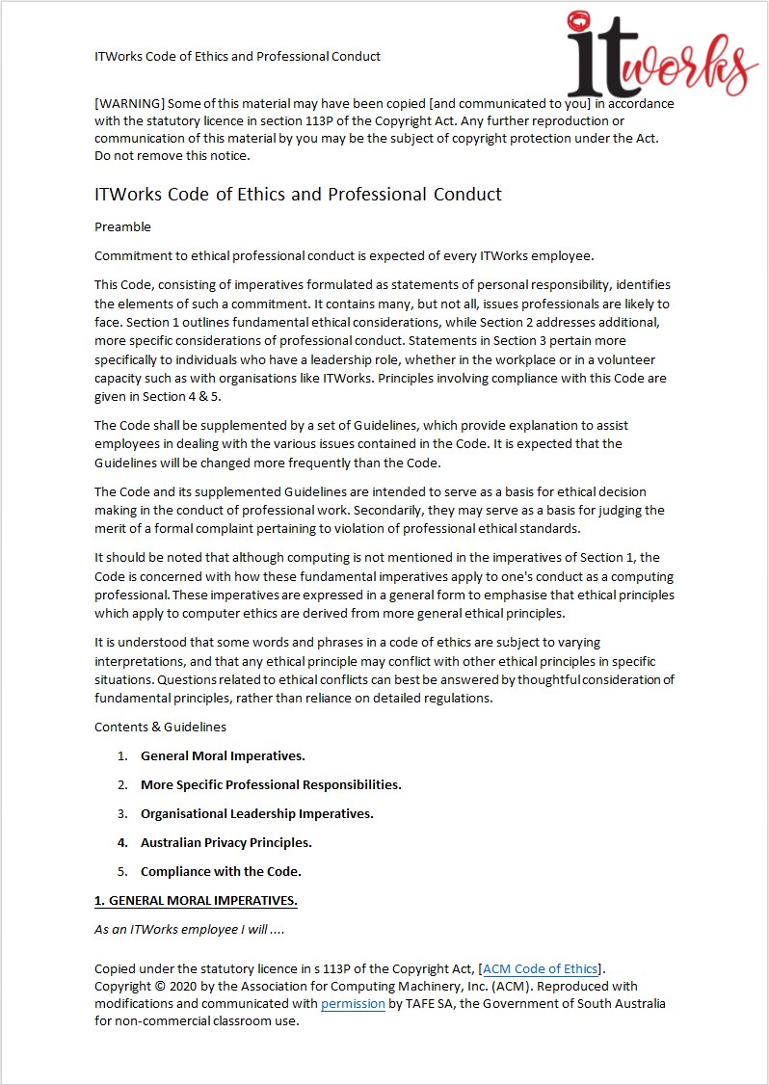

1. Your ITWorks supervisor has requested that you complete the table below and use it to list your examples of legislation (from question one) and describe how the ITWorks COE addresses this legislative requirement (approx. 100 words across the three sections):

|  |  |
| --- | --- |
| Legislation | ITWorks COE section/clause (ie 1.x) & Description |
| IP: | 1.6 |
| Copyright: |  |
| Privacy: |  |

1. Scenario update: you have been promoted to the ‘ethical liaison’ role/position at ITWorks and ITWorks management have sought your input to COE section/clause 4.13. ITWorks management want to know if you think this section should have a recommended time frame, you are to review the policy and determine:  
   1. Determine if the COE meets current industry standard requirements (approx. 20 words):

ANSWER:

* 1. What is a reasonable timeframe for the COE to be updated?

ANSWER:

1. ITWorks management have sought your input to COE section 1. ITWorks management want to know if you think this section should include something about ‘acceptable behavioural norms’ both at work and outside of the business hours by ITWorks employees. You are to review the policy and recommend if an update is required to bring the COE up to industry standard and briefly explain why (approx. 25 words ).

ANSWER:

1. It has been decided by ITWorks management that the ‘acceptable behavioural norms’ clause is required in the ITWorks COE, you are to draft this COE update below and it must include at least two new guidelines (approx. 40 words total/maximum):

ANSWER:

1. Scenario update: ITWorks management have reviewed and approved your changes & updates. Following the COE guidelines, draft an email to all ITWorks staff to inform them of your new or revised clauses in the ‘ITWorks Code of Ethics and Professional Conduct’ policies (relating to questions 4 & 6 above). Staff must be notified that these changes are to become effective within two weeks from the date of the email.

Your email must also briefly list and explain the updates and/or changes.   
(approx. 100 words & DO NOT SEND EMAIL!)

EMAIL DRAFT SCREENSHOT   
(please make the screenshot as legible to read as possible/reasonable):

1. A colleague has forwarded the email below to you:

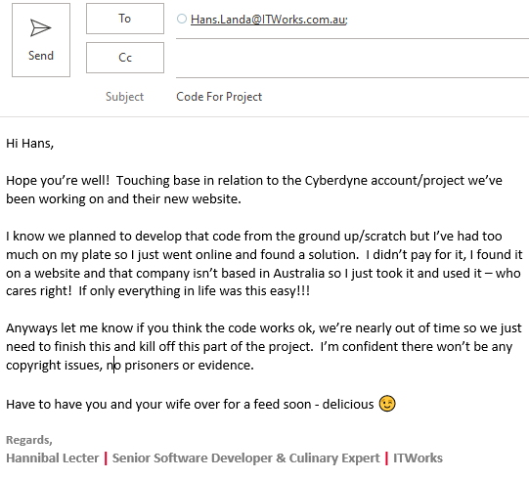

In your role as the ‘ethical liaison’ you must (approx. 80 words total):

1. Discuss at least three things that Hannibal has done wrong, include the comments in the email that indicate this.
2. Define at least one breach for each relevant section of the ITWorks COE by Hannibal?

ANSWER (a):

ANSWER (b):

1. In your new role as ‘ethical liaison’ at ITWorks, it has been deemed by management that a ‘grievance procedure’ is required. ITWorks has never had anything like this before, a search of the SharePoint repository will confirm this.  
     
   You are to draft a ‘grievance procedure’ that is to be added in the ITWorks COE. This new procedure must be developed for all ITWorks employees and enable them to (approx. 100 words total/maximum):
2. Lodge a complaint about something that occurred during the employees ITWorks duties and/or
3. Question or challenge a sanction or disciplinary action imposed by ITWorks management for a breach of the ITWorks COE

ANSWER:

1. Following your work developing the ITWorks ‘grievance procedure’ above, draft an email to all ITWorks management to inform them of your proposed procedure in the ‘ITWorks Code of Ethics and Professional Conduct’ document and briefly explain what the procedure is. The email must seek feedback from ITWorks management on the new procedure aiming for final signoff of the policy & procedure and subsequent release to the wider organisation (approx. 80 words & DO NOT SEND EMAIL!)

EMAIL DRAFT SCREENSHOT  
(please make the screenshot as legible to read as possible/reasonable):